**Bug ID:** B001/IGLP_001

Step 1: open chrome browser.

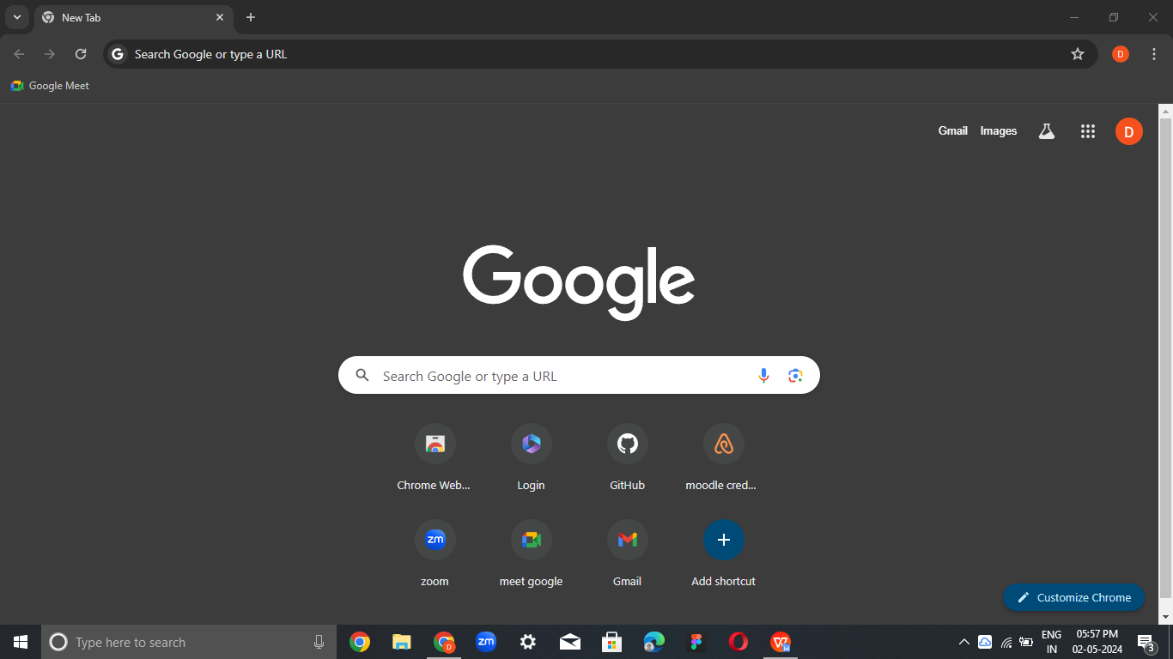

Step2: Enter url in the search box.

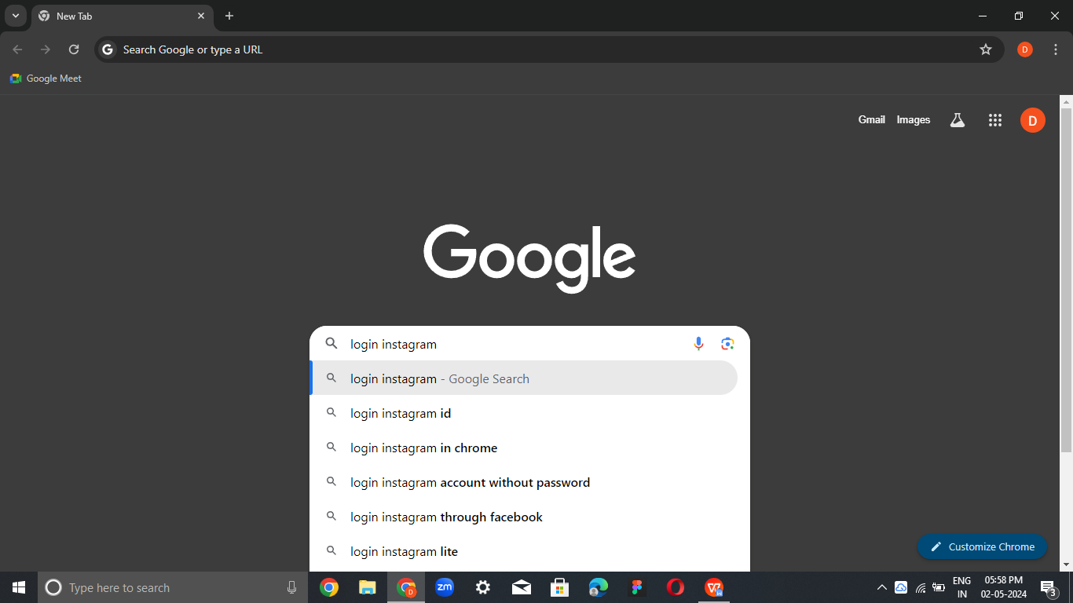

Step3: open the login page.

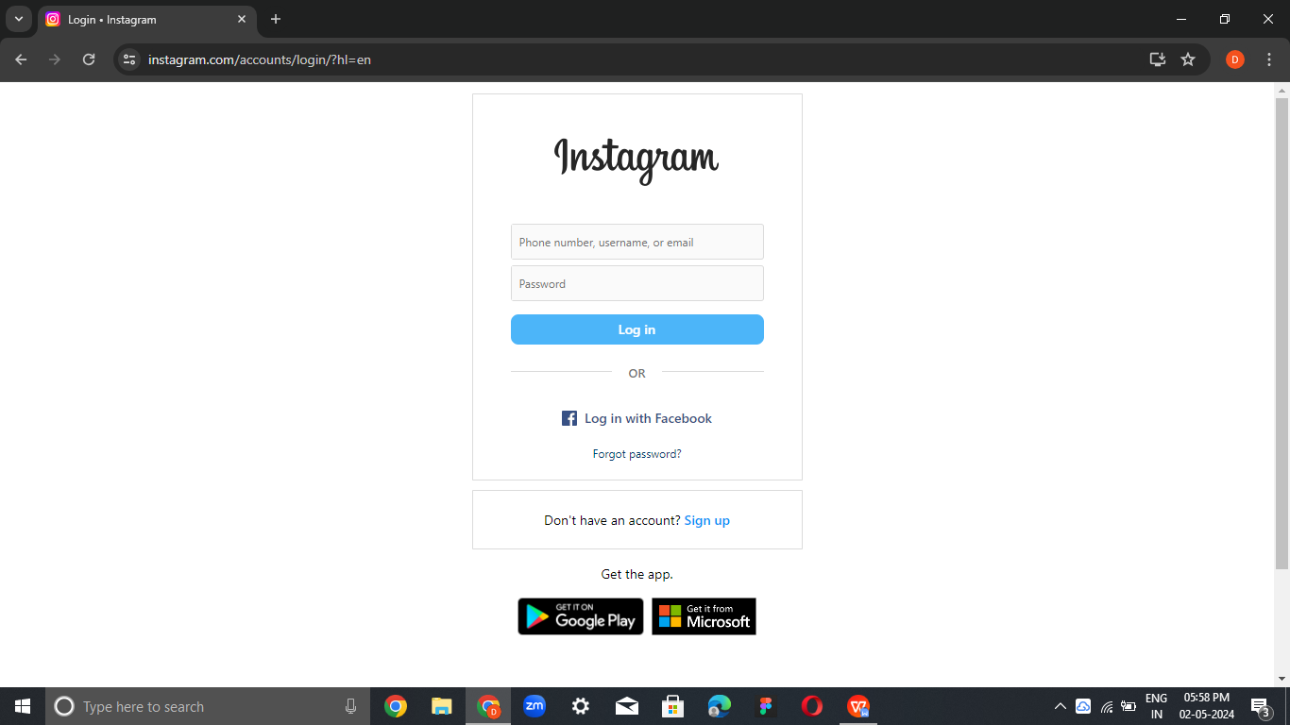

Step4: Enter the details then click login button.

